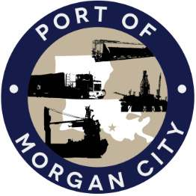

AGENDA

MORGAN CITY HARBOR AND TERMINAL DISTRICT
Regular Meeting of June 12, 2017 – 5:00 p.m. – 7327 Highway 182

1. Call to Order and Roll Call

2. Invocation and Pledge of Allegiance

3. Minutes
A. Regular Meeting of May 8, 2017

4. Finance Report
A. Presentation and discussion of financial reports for May 2017 – Deborah Garber
B. Invoices

5. Guest(s)/Public Comment
A. United States Coast Guard
B. Corps of Engineers, New Orleans District

6. Raymond “Mac” Wade - Executive Director’s Report
A. Consultant – Michael Knobloch, Knobloch Professional Services, LLC
B. Consultant – Clay Breaud, Providence/GSE
C. Consultant – Michael Lowe, GIS Engineering, LLC
D. Consultant - Charles Brittingham
E. Cindy Cutrera, Manager of Economic Development

7. Gerard Bourgeois - Legal Report

8. New Business
A. Discussion and any action on request for Letter of “No Objection” from CB&I on behalf of Conrad Shipyard, LLC regarding mooring dolphin; bulkhead and pier removal; CAP mono-piles and sheet pile; maintenance dredging
B. Discussion and any action on contract with Knobloch Professional Services
C. Discussion and any action on audit engagement services due to the new Statewide Agreed Upon Procedures (SAUP)

9. Old Business
A. Discussion and any action on leasing, improvements, maintenance and repairs to facility(ies), including Coast Guard lease(s)
B. Discussion and any action regarding the U.S. Department of Homeland Security grant program, including request for proposals, bids, purchases, project management, generators, computer data system and NOAA ports system(s)
C. Discussion and any action on Government Operations and Emergency Center including bids, purchases, payments, leasing and Facility Planning and Control
D. Discussion and any action on Atchafalaya River Channel including dredging and sediment management, equipment purchases, reports, survey services, consulting services and economic study(ies)
E. Discussion and any action on 2016 flood fight.

10. Adjournment

In accordance with the Americans with Disabilities Act, if you need special assistance, please contact Tori Henry at 985-384-0850, describing the assistance that is necessary.

